OBJECT ORIENTED PROGRAMMING USING JAVA

NAME : T.R.DIVYASREE

DEPT & SEC : CSE & B

ROLL NO : 230701083

WEEK : 8

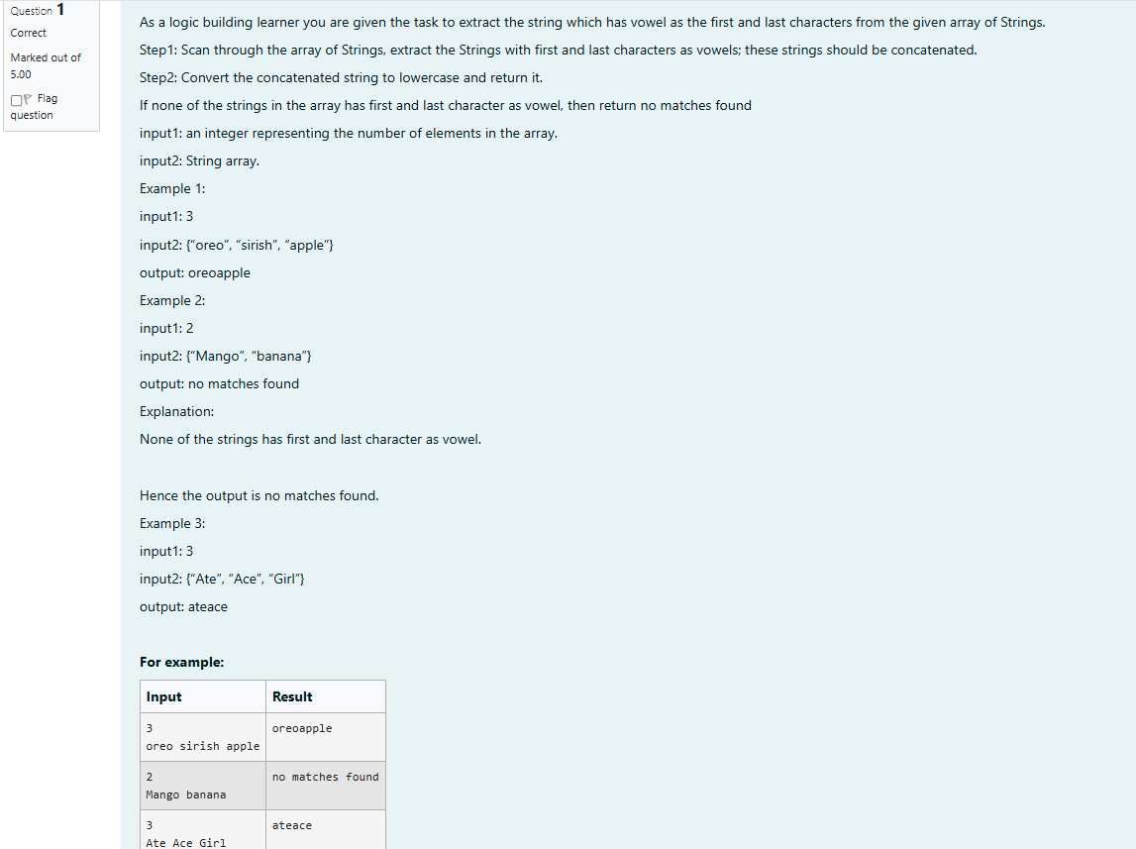

import java.util.Scanner;

public class Main{

public static void main(String[] args){

Scanner sc=new Scanner(System.in);

int a=sc.nextInt(),c=0;

sc.nextLine();

String []arr=sc.nextLine().split(" ");

for(int i=0;i<a;i++){

String w=arr[i].toLowerCase();

char s1=w.charAt(0);

char s2=w.charAt(arr[i].length()-1);

int f1=0,f2=0;

if(s1=='a' || s1=='e' || s1=='i' || s1=='o' || s1=='u') f1=1;

if(s2=='a' || s2=='e' || s2=='i' || s2=='o' || s2=='u') f2=1;

if(f1==1 && f2==1)System.out.print(w);

else c++;

}

if(c==a)System.out.println("no matches found");

}

}

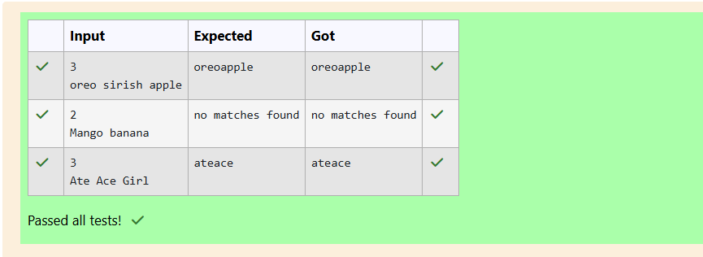

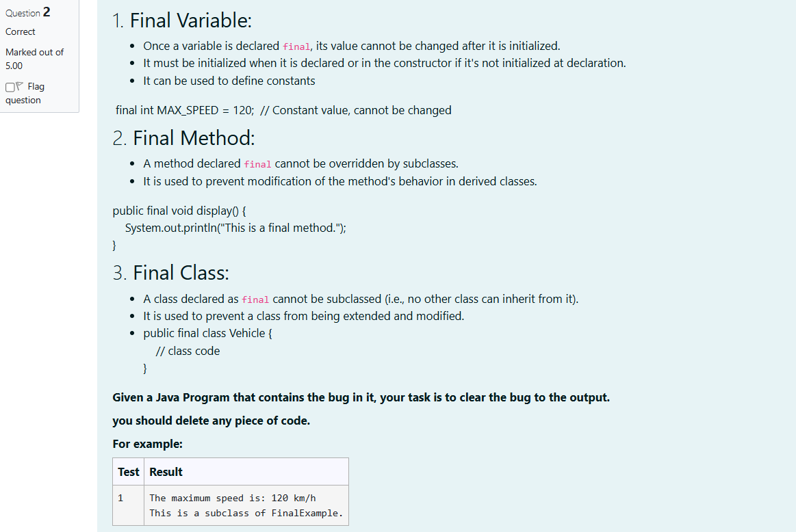

class FinalExample {

// Final variable

final int maxSpeed = 120;

// Final method

public final void displayMaxSpeed() {

System.out.println("The maximum speed is: " + maxSpeed + " km/h");

}

}

class SubClass extends FinalExample {

/\*public void displayMaxSpeed() {

System.out.println("Cannot override a final method");

}\*/

// You can create new methods here

public void showDetails() {

System.out.println("This is a subclass of FinalExample.");

}

}

class prog {

public static void main(String[] args) {

FinalExample obj = new FinalExample();

obj.displayMaxSpeed();

SubClass subObj = new SubClass();

subObj.showDetails();

}

}

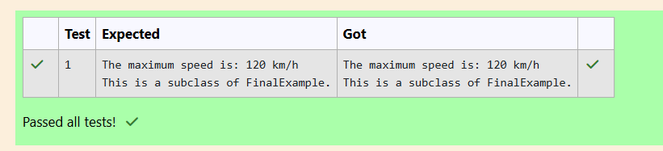

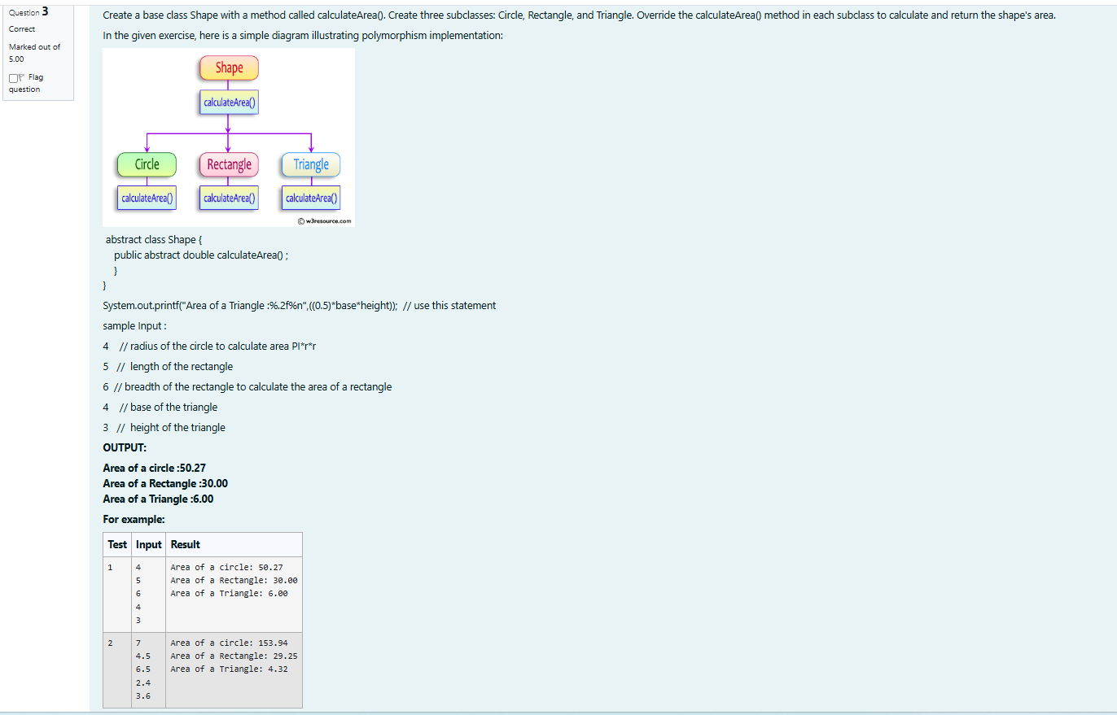

import java.util.\*;

abstract class Shape {

abstract double calculateArea();

}

class Circle extends Shape {

private double radius;

Circle(double r) {

radius = r;

}

double calculateArea() {

return Math.PI \* radius \* radius;

}

}

class Rectangle extends Shape {

private double length;

private double breadth;

Rectangle(double l, double b) {

length = l;

breadth = b;

}

double calculateArea() {

return length \* breadth;

}

}

class Triangle extends Shape {

private double base;

private double height;

Triangle(double b, double h) {

base = b;

height = h;

}

double calculateArea() {

return 0.5 \* base \* height;

}

}

public class Prog {

public static void main(String[] args) {

Scanner sc = new Scanner(System.in);

double r = sc.nextDouble();

Shape circle = new Circle(r);

System.out.println("Area of a circle: "+String.format("%.2f",circle.calculateArea()));

double length = sc.nextDouble();

double breadth = sc.nextDouble();

Shape rectangle = new Rectangle(length, breadth);

System.out.println("Area of a Rectangle: " + String.format("%.2f",rectangle.calculateArea()));

double base = sc.nextDouble();

double height = sc.nextDouble();

Shape triangle = new Triangle(base, height);

System.out.println("Area of a Triangle: " + String.format("%.2f",triangle.calculateArea()));

}

}

